DBModel User Guide
DBModel User Guide 1
1. Installation 3
1.1. Windows Installer 3
1.2. Application Updates 3
2. Application Window Overview 3
2.1. Menu Bar 4
2.2. Toolbar 5
2.3. Connection Status 5
2.4. Control Bar 6
2.5. Property View 6
2.6. Navigator Views 7
2.6.1. Project Navigator 7
2.6.2. Model Navigator 10
2.6.3. Procedure Navigator 11
2.7. Workspace 13
2.7.1. Changing Workspace Layout 14
2.7.2. Managing View and Editors 15
2.7.3. Model Workspace 17
2.7.4. Procedure Workspace 23
3. Databases & Connectivity 29
3.1. Database Information 29
3.2. Connection Dialog 31
3.2.1. Establish a connection using URL 31
3.3. Connection Manager 33
3.3.1. Adding JDBC Drivers 34
4. Databases Design 34
4.1. Select a Database into the Project 35
4.2. Create a Database into the Project 36
4.3. Synchronize the Model with Database 37
4.4. Context Menu 38
5. SQL Editor 38
5.1. Introduction 39
5.2. Auto-Complete 39
5.3. Execute Single Query or Scripts 40
5.4. Drop SQL Editors 41
5.5. Save SQL Editor 41
6. Model Design 41
6.1. Design Model Online or Offline 41
6.2. Add tables to Model layout 42
6.3. Remove Table View 43
6.4. Establish Table Relationship 43
6.5. Foreign Key Routing 44
6.6. Change Foreign Key Type 45
6.7. Foreign Tools 46
7. Procedure Design 46
7.1. Introduction 46
7.2. Start Procedure Designer 47
7.3. Procedure Toolbar 47
7.4. Add tables to Procedure Layout 49
7.5. Remove Table View 50
7.6. Establish Table Relationship 50
7.7. Foreign Key Routing 51
7.8. Change Foreign Key 51
7.8.1. Change Foreign Key Type 51
7.8.2. Change Join Type 52
7.8.3. Change Foreign Key Direction 52
7.9. Choose the Columns to Select 53
7.10. Step Information Window 53
7.10.1. Where Conditions 54
7.11. Join Further Tables to the Procedure 57
7.12. Generate next step 57
7.13. Execute Generated SQL 58

Installation

Windows Installer

The installer distribution is the recommended way to install DBModel in Windows . It contains all required dependencies. In addition, the installer automatically upgrades DBModel to the new version if a previous version has already been installed. To install DBModel, run the installer executable and follow the instructions on its screens.

Application Updates

This feature is available only in Windows.
The Check For Update menu helps you to check if a new versions is available in the Help . If a new version is available, it will automatically start upgrade and the installer will be downloaded and launched upon completion. Note that DBModel itself will be gracefully closed to avoid data loss.

Application Window Overview
The DBModel window contains a menu bar, a toolbar, a model/Sequence workspace with one or more editors and views, and a connection status bar:
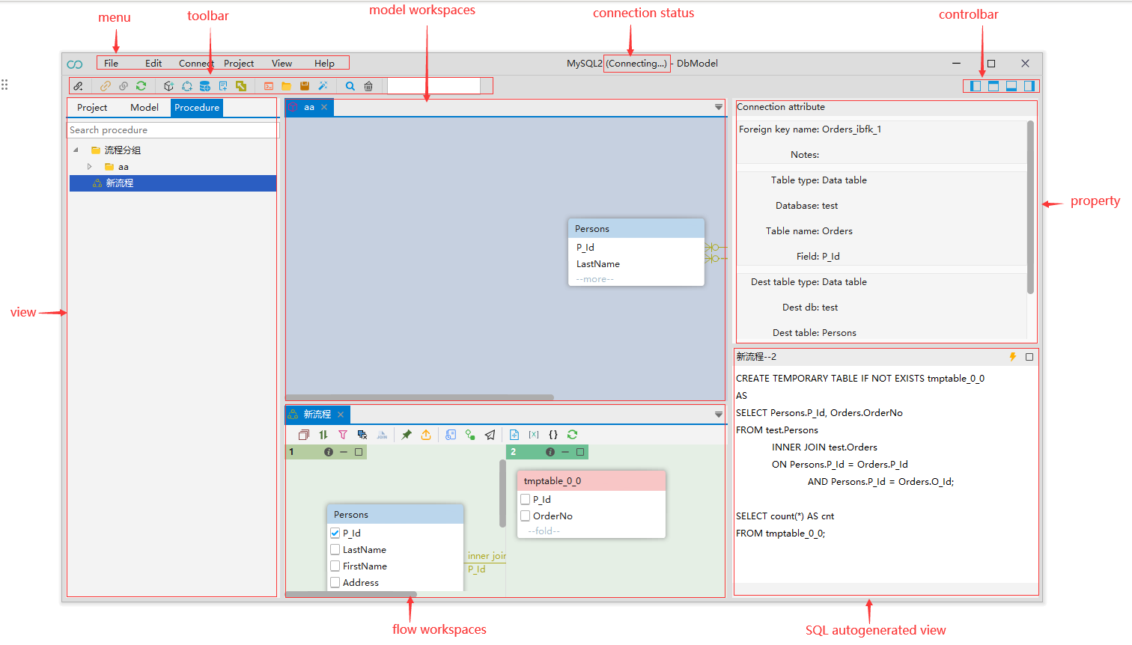

Menu Bar

By default, the menu bar contains the following menus:
- The File menu contains menu items for creating projects, database connections, project-related items.
- The Edit menu includes items to manage the look of DBModel window: show/hide [X], add/delete foreign key operations, set table or field alias.
- The Connect menu allows the management of connections, switching to different connection , reconnecting to and disconnecting from a database.
- The Project menu contains menu items for creating model or sequence files|groups, SQL editor console and database-related items.
- The View menu used to manage the show/hide of windows: model views, Sequence views, project window and property window,etc.
- The Help menu contains product updates, product information, and help information.

Toolbar

The toolbar contains buttons for the most basic and frequently used commands:
Some buttons are enabled (colored) and others are disabled (gray). The sets of enabled and disabled buttons change depending on which editor is active in the workspace. Only enabled buttons can apply to the active view or editor.

Connection Status

Connection status Displays the status of the connection to the current physical database .

Control Bar

The Control toolbar is used to control the display and hiding of views other than the menu bar and toolbar:

Property View

The property view displays the primary and foreign key relationships of the currently selected line, including source and target table information, primary and foreign key information, connection type, and so on:
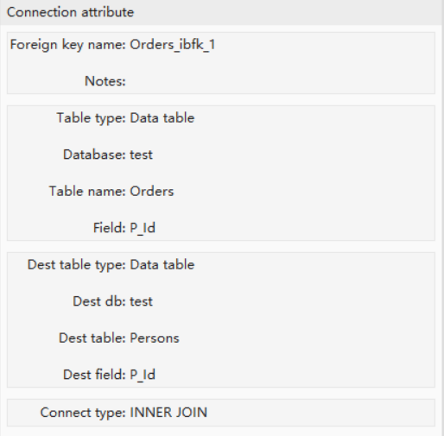

Navigator Views

The view is divided into three tabs: project, model, and procedure. The project tab contains databases, tables, views, fields and other database-specific objects; the model and procedure tabs are used to manage model and procedure files, respectively. Depending on the current view, different context menus are displayed when you right-click the mouse.

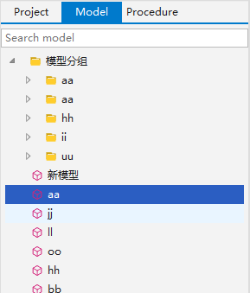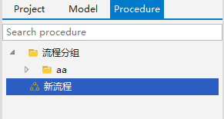

Project Navigator
Project Navigator is the main view to work with the structure and content of databases. To open Project Navigator, on the View menu, click show project window. For information on how to change the view layout, please see the section Changing Workspace Layout .
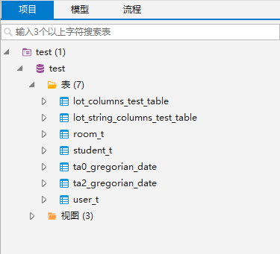
Project Navigator is a tree-like list of objects. Each object in the tree has its own context menu. The tree contains the following objects:
- Folders -
- Database connections - and other (icons differ depending on the database type)
- Database objects - such as Tables , Views , Columns , etc.
To open the context menu for an object, right-click the object in the tree. The following table summarizes the context menu items for all types of objects that may appear in the tree. Note that the presence or absence of the context menu items for an object depends on the database and object types.
Menu item | Description
Edit Project | Opens the Project Configuration window that allows configuring Project settings
Delete Project | Delete Project  WARNING! The Delete removes the object not only from the tree but also from the file system, and this action is irreversible.
Connect | Attempts to connect to the database
Disconnect | Disconnects from the database
Reconnect | Checks the status of connection, if it is broken, attempts to reconnect
Refresh | Depending on the object, refreshes the object itself, or its parent, or its subnodes – mostly used for refreshing tables and databases
new [object] | Opens an editor in which you can specify properties and save the new object
View [objects] | View object details in a separate viewer
Edit [object] | Edit object details in a separate editor
Generate SQL | Opens a submenu on which you can select the type of SQL query to generate:  - SELECT  - INSERT  - UPDATE  - DELETE  - CREATE  Clicking one of the items (for example INSERT) generates a relevant query in a new SQL window.

For information on how to filter database objects in Project Navigator, please see the Filter Database Objects article.

Filter Database Objects
In the Project you can filter database objects to some of them from the view. You can filter databases, tables and views.
You can to filter objects by the names of tables and views using the filter field :
To filter objects by name, type the object name in the filter where three or more characters are needed. The tree dynamically updates to show databases/tables/views with that name. To reset the filter, Clear name in the field.

Model Navigator
Model Navigator is the main view to work with the structure and file of models. To open Model Navigator, on the View menu, click show model window. For information on how to change the view layout, please see Changing Workspace Layout article.
Model Navigator is a tree-like list of objects. Each object in the tree has its own context menu. The tree contains the following objects:
- Folders -
- Model files - .
To open the context menu for an object, right-click the object in the tree. The following table summarizes the context menu items for all types of objects that may appear in the tree. Note that the presence or absence of the context menu items for an object depends on the object types.
Menu item | Description
Add [object] | Opens an editor in which you can specify properties and save the new object
Delete [object] | Delete the object
Edit [object] | Opens the object in a separate editor
Copy | Copy & Paste the model file

For information on how to filter Models objects in Models Navigator, please see the Filter Models Objects article.

Filter Models Objects
In the Models Navigator you can filter Models objects to some of them from the view. Only models can be filtered, not folders.
You can to filter objects by the names of models using the filter field :
To filter objects by name, type the object name in the field where three or more characters are needed. The tree dynamically updates to show models with that name. To reset the filter, Clear name in the field.

Procedure Navigator

Procedure Navigator is the main view to work with the structure and file of flows. To open Sequence Navigator, on the View menu, click show procedure window. For information on how to change the view layout, please see the Changing Workspace Layout article.
Procedure Navigator is a tree-like list of objects. Each object in the tree has its own context menu. The tree contains the following objects:
- Folders -
- Sequence files -
To open the context menu for an object, right-click the object in the tree. The following table summarizes the context menu items for all types of objects that may appear in the tree. Note that the presence or absence of the context menu items for an object depends on the object types.
Menu item | Description
Add [object] | Opens an editor in which you can specify properties and save the new object
Delete [object] | Delete the object
Edit [object] | Opens the object in a separate editor

For information on how to filter procedure objects in Procedure Navigator, please see the Filter Procedure Objects article.

Filter Procedure Objects
In the Procedure Navigator you can filter procedure objects to some of them from the view. Only flows can be filtered, not folders.
You can to filter objects by the names of flows using the filter field :
To filter objects by name, type the object name in the field where three or more characters are needed. The tree dynamically updates to show Procedures with that name. To reset the filter, Clear name in the field.

Workspace

Views are windows within the workspace that provides interface presentation and navigation information. For more detailed information, you can jump to the appropriate view section.
Model views can be used to build model relationships between tables, which can be built by dragging&dropping tables from the Project Navigator to the Model view. For more information , see the Model article.
SQL Editors are windows in which you can interact with the content of files and databases. For more information , see the SQL Editor article.
By interacting with the UI，procedure views provide the ability to automatically generate database-specific SQL scripts that previously required large manual input , greatly reducing the workload of developers. Meanwhile thanks to the function signatures provided in DBModel, you can easily complete SQL script development tasks involving functions. For more information , see the Procedure Workspace article.
Property window display the current foreign key connection information.For more information , see the Property article.
The SQL script of the current step is displayed in the SQL auto generation editor. When the Sequence is updated, the contents in the editor are updated synchronously. You can switch to a different step or a different Sequence to display the script information for the current step or flow. The editor also supports the script execution function and can directly run the generated script, which greatly meets the design and debugging requirements of the program.For more information , see the SQL auto generation article.
Several views and editors can be opened simultaneously in the workspace, but only one can be active at a time.
You can change the layout of the workspace by opening and closing views.

Changing Workspace Layout

There are two ways to change the workspace layout:

1、To hide/show the up, down, left and right views by clicking the corresponding button on the control bar :
- - to hide/show the left window .
- - to hide/show the top window .
- - to hide/show the bottom window .
- - to hide/show the right window .
2、From the menu view, select the corresponding option：
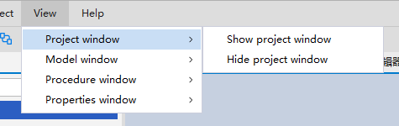
Note: For the model and Procedure views, you can close the corresponding view window by clicking the icon on the tab right.

Managing View and Editors

All model and Procedure views and editors have the Close and Others button:

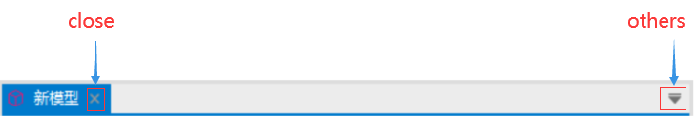

Procedure step management:
All the steps of the Procedure view have the minimize, maximize, and restore buttons:
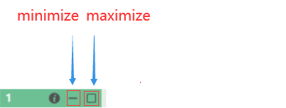

To maximize a step, do one of the following:
- Click the Maximize button in the upper-right corner of the step.
When a step is maximized, the other steps appear as thumbnails at the bottom of the workspace.
To minimize a step, do one of the following:
- Click the Minimize button in the upper-right corner of the view.
- Click the Maximize button in the upper-right corner of any step other than this step.

The Maximize button changes to the Restore button when a step is Minimize.
To restore a minimized step to its previous position, click the Restore button .

Model Workspace
The model workspace is used to provide model design functions, including the addition and deletion of table views, and the design of relationships between tables.
Model workspace contains a series of objects. The following is a description of the relevant legend for each object:
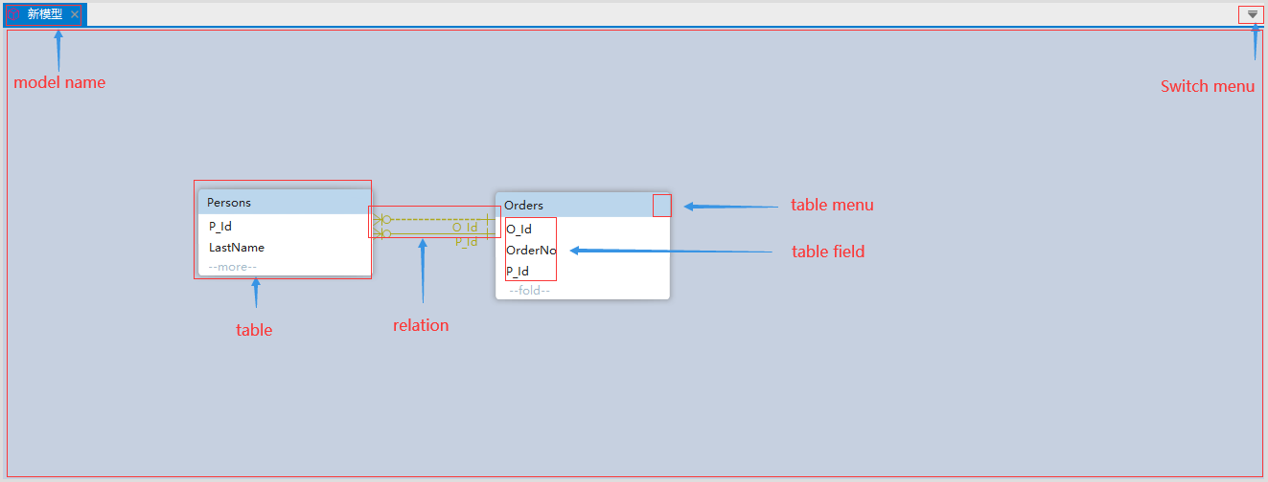
Item Description:
Item | Description
Model Name | displays the name of the data model in the upper- left corner.
Switch menu | Used to switch between different models
table | Table view
relation | relationship between tables
Table menu | Table toolbar
Table field | fields belonging to the current table

For information on how to add table from Project Navigator to the model workspace, please see the Add Table View article.
For information on how to View Table Relations Properties, please see the Property View article.
For information on how to remove table from model workspace, please see the Remove Table View article.
For information on how to establish relationship between tables, please see the Establish Table Relationship article.

Add Model Layout
Add model layout by right-clicking on an folder item or empty place in the models navigator. Choose the Add [model|group]option.
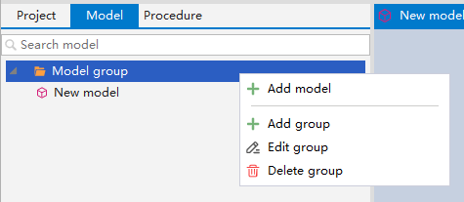
Type the name of the model file in the pop-up window. After completion, the created model file can be seen in the selected model folder.
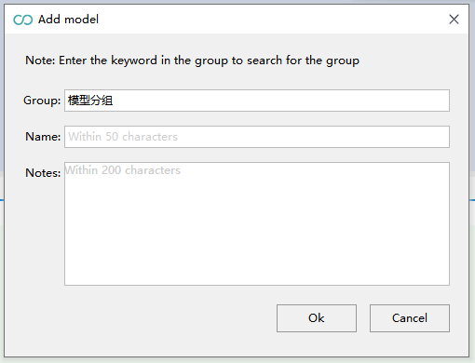
You can also search for the location where the file was created.
For example , search the aa folder as follow:
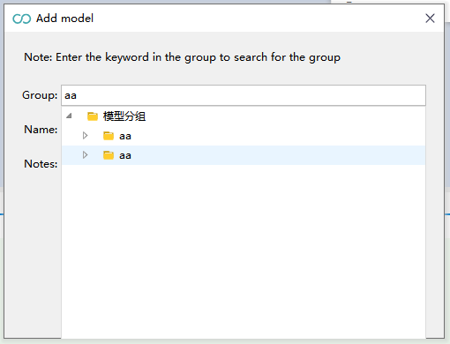

Delete Model Layout
Layout can be deleted by right-clicking the model file and selecting the delete menu in the context menu.
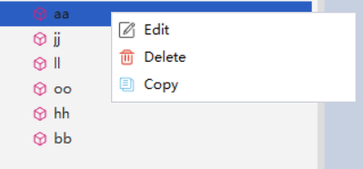
However, when closing a layout, DbModel will preserve the layout in the design model ( close the layout but keep a copy in the design model, so it can be reopen at any time ).
The same is done with the other data tools: Procedure Layout .

Table Menu items
The toolbar is integrated into the title bar at the top of the table view.
To open the Table menu, click the View Menu button located in the upper-right corner of the window. The Table menu contains the following items:
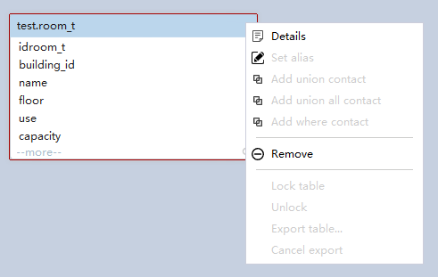
Item | Description
Details | Show table properties.
Remove | Remove the table from the model.

Foreign key Menu items
The menu bar is integrated into the foreign key line. To open the Foreign Key menu, right-click the foreign key line. It has the following items in the menu:
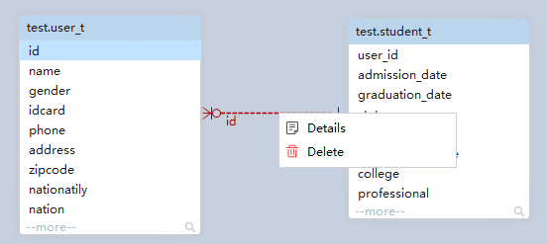
Item | Description
Details | Show table properties.
Remove | Remove the table from the model.
Convert table foreign key | Synchronize the model relationships to the physical database.

Show Table related

Click the edit menu on the menu bar, and select the show/hide menu item, then the following functions are available:
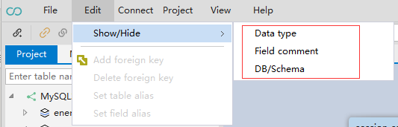
Menu item | Description
Show Data Type | Displays the data type of the table field
Show Comment | Show Table Field Comment
Show Database/Schema | Displays the name of the database to which the table belongs

For information on how to filter Models objects in Models Navigator, please see the Filter Models Objects article.

Procedure Workspace
Procedure Workspace is mainly used to generate SQL scripts. The UI interface replaces the traditional hand-tapping coding mode, which improves the coding efficiency and reduces the error rate at the same time. For example, SQL coders often encounter comma problems in Chinese and English.
The core idea of the Procedure is step. Procedure Sequence contains a series of subqueries, called step. Procedure Sequence uses a step-by-step approach to write code, and the UI SQL Window with steps makes the logic clearer and easier to understand.
The code generated by Procedure Workspace can be run instantly with one click, which greatly facilitates the debugging of the program.
Procedure Workspace supports parallel SQL code generation which which makes it possible to generate more complex code.
Procedure Workspace contains a series of objects. The following is a description of the relevant legend for each object:
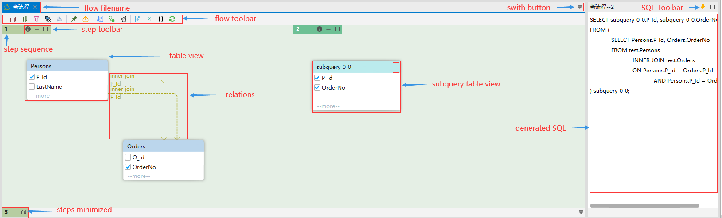
Item Description:
Item | Description
Sequence filename | displays the name of the file model in the upper- left corner.
Switch button | Used to switch between different models
Procedure toolbar | buttons that interacts with the user to generate SQL code
Step toolbar | Step buttons that interacts with the user to control the step visibility
Step sequence | Step number, starting from 1
table | Table view
relations | relationship between tables
Subquery table view | Temporary table view generated by an intermediate subquery step.
Table field | fields belonging to the current table
SQL Toolbar | Buttons used to operate auto-generated SQL, including run and maximize
Generated SQL | Auto-generated SQL

For information on how to add layout into the Procedure Workspace, please see the Add Procedure Layout article.
For information on how to remove layout from Procedure Workspace, please see the Delete Procedure Layout article.
For information on how to View Table Menu items , please see the Table Menu items article.

Add Procedure Layout
The operation of add Procedure Layout is the same as that in the Model Design. Please refer to the Model Workspace section.

Delete Procedure Layout
The operation of Delete Procedure Layout is the same as that in the Model Design. Please refer to the Model Workspace section.

Table Menu items
The toolbar is integrated into the title bar at the top of the table view.
To open the view menu, click the View Menu button located in the upper-right corner of the window. The view menu contains the following items:
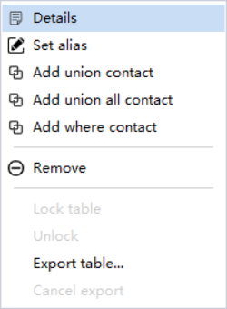
Item | Description
Details | Show table properties.
Set alias | Set alias for the table
Add [X] contact | Add x relationship to the other tables
Remove | Remove the table from the model.
Lock table | Locked table can not be processed and without information in the next step procedure.
unlock | unlock table
Export table | Export table data to the table, which can be temporary or physical.
Cancel export | Cancel export table data

Foreign key Menu items
You can open the Foreign menu just by right-clicking on the line.
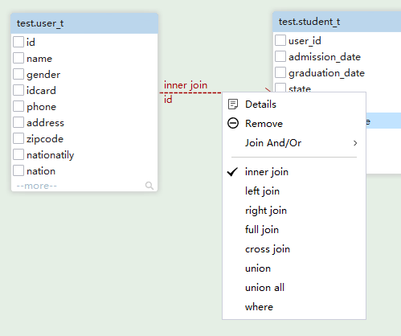

Item | Description
Details | Show connection properties.
Remove | Remove the line from the model.
Join And/Or | Shortcut to create a join relationship
[X] join | Create a specific join relationship
Union[X] | Create a union relationship
where | Create a where relationship

Show Table related
The operation of Show Table related is the same as that in the Model Design. Please refer to the Model Workspace section.

Databases & Connectivity
DbModel can connect to any SQL or few NoSQL databases. Proper JDBC Driver is Required. When connecting a database, DbModel automatically downloads the JDBC Driver from its public web repository.
To learn how to configure the connection , click here. Some databases may require to enable remote connections, enable TCP/IP, grant user access or enable firewalls.
If the JDBC driver you're looking for is missing from the JDBC driver list you can upload the driver in DbModel .

Database Information
The supported database types are as follow:
- Amazon Athena
- Apache Ignite
- Aurora MySql
- AzureSQL
- Cache
- Cassandra
- Databricks
- Db2
- Derby
- Elasticsearch
- Exasol
- Filemaker
- Firebird
- Frontbase
- GoogleBigQuery
- GoogleCloudSpanner
- HBase
- HSQL
- Hive
- Informix
- Ingres
- Interbase
- JDataStore
- MariaDb
- Mimer
- MongoDb
- MySql
- Oracle
- OrientDb
- Pervasive
- Postgres
- Redshift
- Salesforce
- SAP Adaptive Server
- SAP Hana
- SAP MaxDb
- Snowflake
- SqlAnywhere
- SqlServer
- Sqlite
- TimescaleDB
- Vertica

Connection Dialog
The connection dialog will let you configure the connection to any database.

Establish a connection using URL

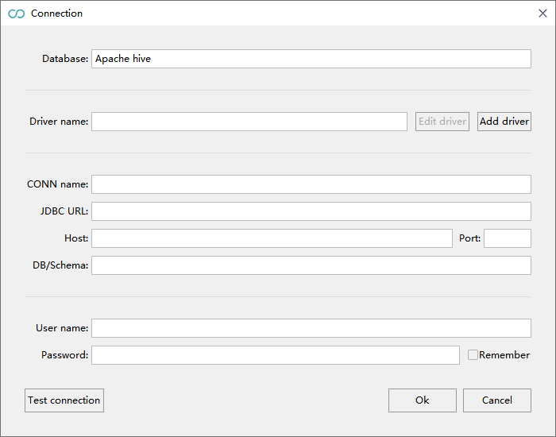
- Select an Database for your database connection.
- The Driver Name is alias used to refer the extension .jar, a plug-in used to connect to the database. The driver will be downloaded automatically by DbModel when selecting the DBMS. The JDBC Drivers are usually provided by the same company who wrote the database software. The drivers are store on disk in the C:\Users\<YourUser>\AppData\Local\DbModel\drivers\...
- Input an Connection Name for your database connection. The alias is used to refer the connection through the application.
- The JDBC URL Template. The JDBC URL is automatically filled in after the driver is added and configured, and does not need to be entered manually.
The URL is a string having a pre-defined format, which contains the most relevant parameters: the host, port, DB/Schema, etc.
DbModel builds the JDBC URL from the values you enter in the host, port, and DB/Schema fields.
- Add driver
You need to configure the corresponding driver jar package to connect. Click the Add Driver button to configure the driver for database connection.
- In the Authentication section, insert the User Name and Password. The credentials are usually defined during database installation or when the user is created in the database.
- The Test connection button helps you to check if the connection to the database is working properly.

Connection Manager
DbModel has full control over the JDBC Drivers. Access the Connection Management from Connect .

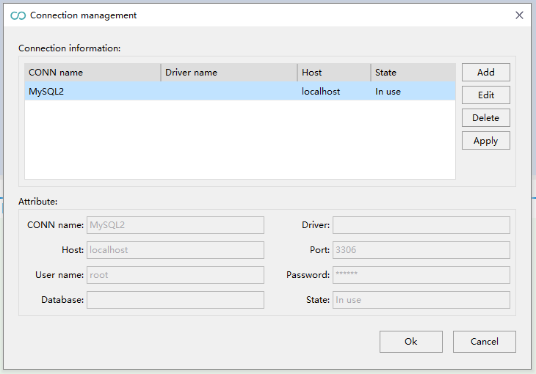
In the Connection Manager you can:
- Add a connection;
- edit connection;
- delete connection;

Adding JDBC Drivers

Access the add connection from Connection Management. For more details, please refer to Establish a connection using Composed URL.

Databases Design
DbModel uses its own model with a copy of the schema structure, separate from the physical database. The DbModelmodel can be created by reverse engineering schema from an existing database or by designing the schema from scratch.
Working with a DbModel model means that:
- Your schema design is database-independent. This enables you to deploy the schema on multiple databases, etc.
- To ensure the schema is the same as in the database choose 'refresh' from the Project Navigator context menu. Read more about the synchronization process.
- The databases, models and procedures will be saved to the model file. You can open the schema without being connected to the database and pick up where you left off. After you connect to the database, you can synchronize the schema.
- You can work on the schema while connected to the database (online) or without a database connection (offline)
  - In the online mode, all the changes made to the schema will be applied to the DbModel model and in the database.
  - In the offline mode, changes will be applied only to the DbModel model. When you reconnect to the database you have to press 'Refresh' if synchronization is required.

Select a Database into the Project
If you created a Database from scratch and want to add it into the Project , all you have to do is:
- Right-click on Project in the Project Navigator.
- Select Refresh .
- If you are not connected to a database, the connection needs be established first. Learn more about how to connect to a database here.
- After establishing a connection, choose the Databases that you want to add/ update.
- After finishing the process, your Database will be updated in the Project .
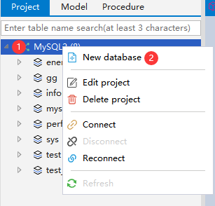

Create a Database into the Project
If you want to create a Database all by yourself , all you have to do is:
- Click on Project in the Project Navigator.
- Select New Database.
- Input the database name, Character set, Character code and Notes. The database name is required, and others are optional.
- Click Ok button, your database will be added into the database.
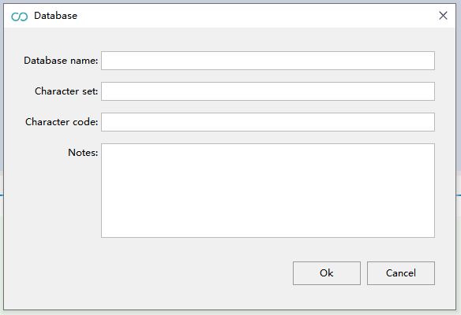

Synchronize the Model with Database
These features are useful if you work on the schema without being connected to the database.
- Select the Refresh button ;
- If your model is not synchronized, the Sync Dialog should pop-up
- If you choose Apply all to model, the changes will be taken over into your local model;
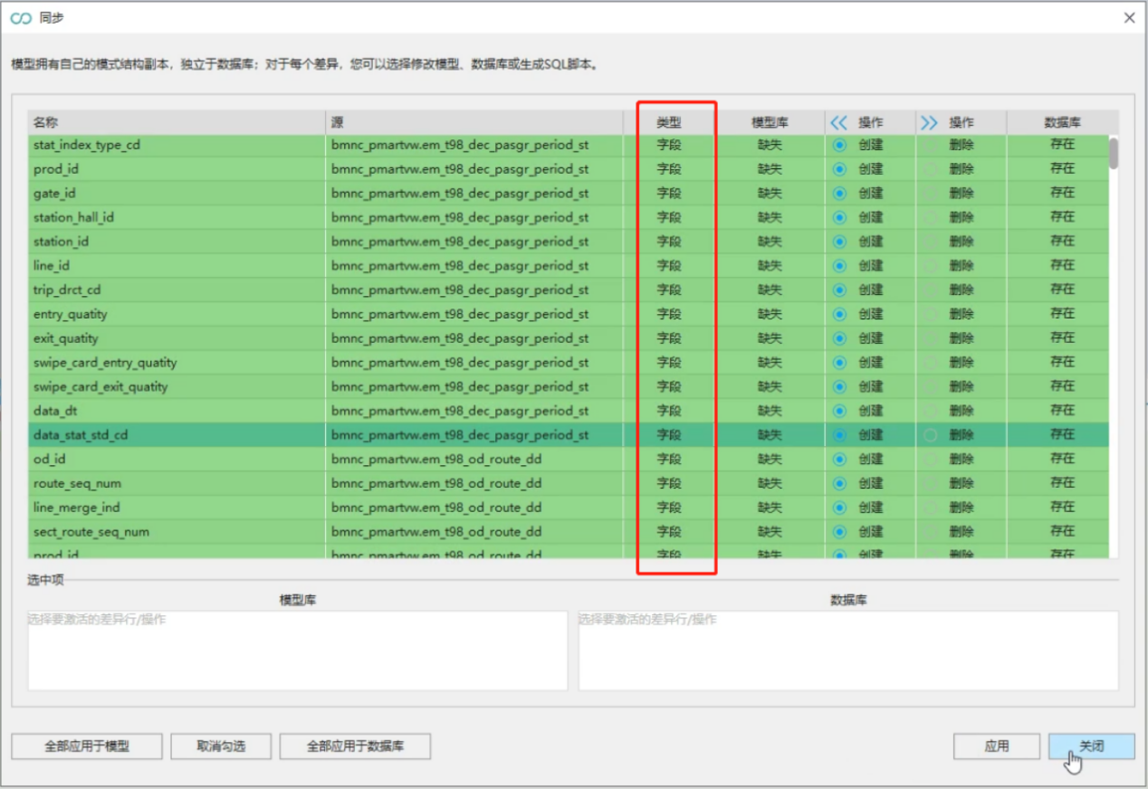

Context Menu

Right-click an object in the Project Navigator tree to access its context menu. For objects under the Database node, see the Project Navigator documentation. Context menus offer basic functionalities such as New, Edit, Delete, and Refresh,etc.

SQL Editor

Introduction
The SQL Editor opens inside the Model layout and can be saved as a separate file in SQL format, and saved editor can be re-opened from the menu.
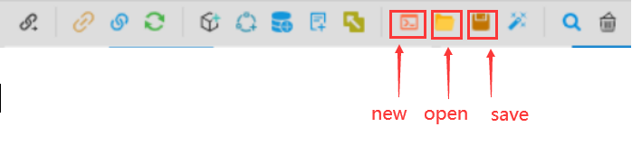
Item | Description
New SQL Editor | Create a new SQL Editor
Open SQL Editor | Open a previous SQL Editor
Save SQL Editor | Save the current SQL Editor to file

Auto-Complete
The editor is auto-complete enabled. Just press TAB or ENTER to enter the full content.
Auto-complete hints include not only database keywords, but also database function signatures.
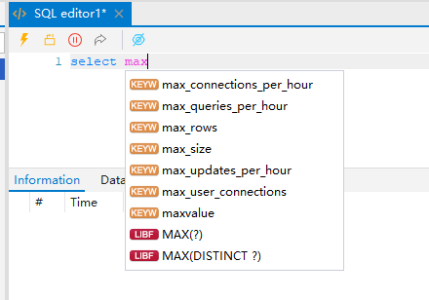

Execute Single Query or Scripts
The editor menu has two distinct buttons, for executing a query while for executing SQL scripts.
- Multiple results will show only the last in the pane.
- the result will be presentation as a table.
- If the error occurred during the execution, the process will stop by errors.
Item | Description
Executing selected portion of script or execute all scripts | execute the selected text or all the statements, Multiple results will show only the last in the pane.
Executing the script where the cursor | execute the statement at the caret position ( ending with ; )
Jump to the error line | place the mouse pointer over the statement that is causing the problem.
Error line Jump to corresponding procedure step | Error line Jump to corresponding procedure step will jump to the procedure step corresponding to the error statement.

Drop SQL Editors
SQL Editors can be dropped by clicking .
When closing an SQL Editor, DbModel will not preserve the editor in the design model .

Save SQL Editor
SQL Editors can be saved to file system .
The saved SQL can be opened again.

Model Design

Design Model Online or Offline
Using DbModel you can design the Model while connected to a database (online) or without database connection (offline).
In the online mode, all table and column changes will be applied in the database.
In offline mode, changes are applied only to the model and synchronized to the file in real time. If you need to synchronize with a physical database, you first need to connect to the database and then synchronize (Refresh). see Synchronize the Model with Database article.
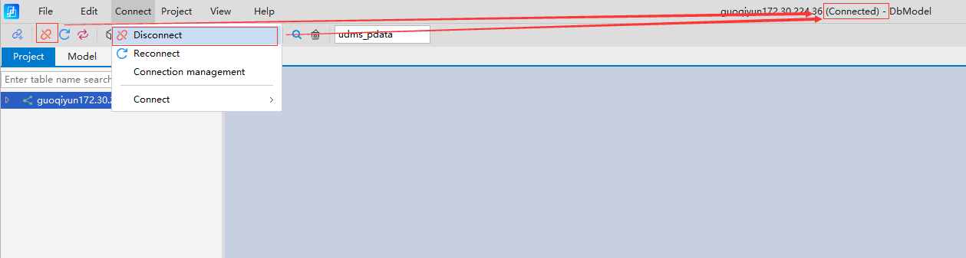

Add tables to Model layout
Add tables from the Project Navigator by drag & drop.
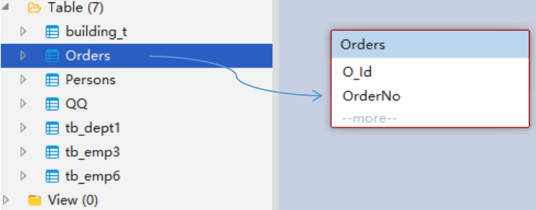
By dragging&dropping tables from the Project Navigator to the Model view, you can see the table view corresponding to the tables in the Model Workspace, right in the position where mouse button is released.
You can also add tables found by filtering Database Objects to the model workspace. For information on how to filter Database objects in Project Navigator, please see the Filter Models Objects article.
A table object can be added to multiple different model workspace.
For tables with existing association relationships, if there are related association tables in the model, the association relationship will be established automatically after they are added to the model.

Remove Table View
Remove Table View means removing the table view from the current model workspace. The actual table object is not deleted, as the table in the database navigation area still exists.
The deleted table view can be added to the workspace again as needed.
After a table that has established an relationship is removed from the model, the corresponding relationship will not be affected.

Establish Table Relationship
After the corresponding table view is created in the model workspace, we can perform a series of operations on the table view, such as creating the primary and foreign key relationship between tables by dragging and dropping table fields. For example, you can establish relationship between P_Id field of table Persons and P_Id field of table Orders. The relationship supports multiple association relationship types such as one to one, one to zero or one, one to one or more, one to zero, one or more, zero, one or more to one, and self-identification. And the relationship between the tables can be edited and delete.
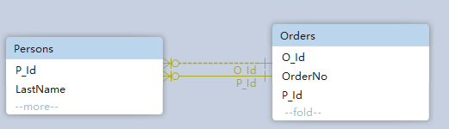
Note: When there are many fields, you can quickly establish table relationships through the "Field Search" function.

Field Search
In situations where there are numerous fields in a table, we have provided a field search feature to assist users in quickly locating the fields they need. This can be accessed by clicking the button ：
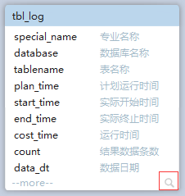
After clicking, enter the full or partial name of the field you wish to search for in the text search box that appears：
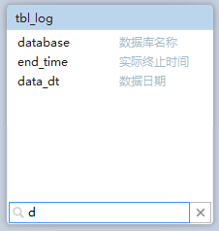
After completing the search, click the button to exit the retrieval mode。

Foreign Key Routing
For how to establish relationships between tables, refer to Establish Table Relationship.
The foreign key line is routed automatically. DbModel creates a disjoint line for each foreign key, which can cause problems.
The line is from table to table mode which this feature can cause the line will point to the unrelated columns.
You can learn about the connection field information from the connection property window in the right side.
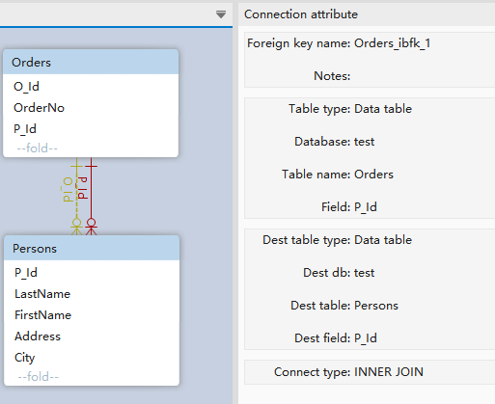

Change Foreign Key Type
Open Foreign key window, For information on how to open it, refer to View Menu items.
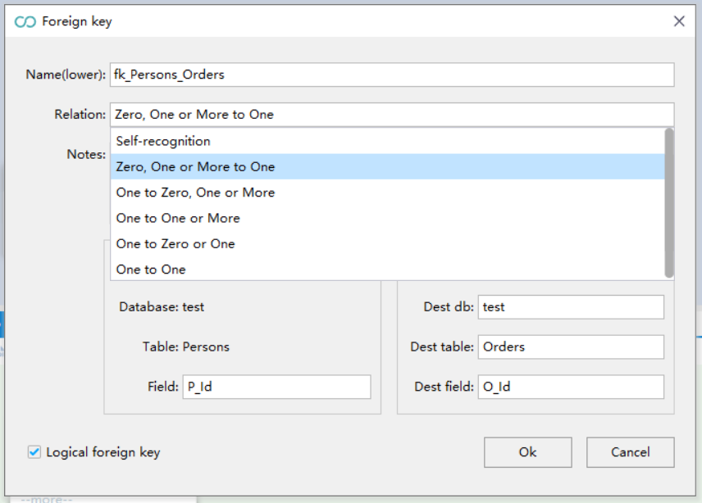
Select a item in the Relation list, press Ok to change foreign key type.

Foreign Tools
You can open the Foreign tool menu just by clicking on the line.
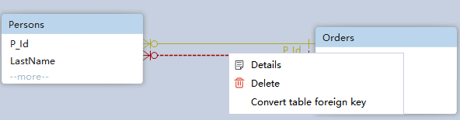

Item | Description
Details | Show connection properties.
Delete | Remove the line from the model.

Procedure Design

Introduction
If you are not an SQL guru and you have to compose database queries, the Procedure Designer may be the right tool for you. Complex SQL business process code can be generated through the user interface of the Procedure Designer,The Procedure Designer opens inside layouts, is saved separately in procedure format file, and can be reopened from the Procedure Navigator Workspace.
Core features:
- Graphical SQL development. Graphical SQL programming greatly simplifies the difficulty of development and improves the efficiency;
- Support database-related functions. It can be used directly through the UI interface, which avoids the trouble of repeatedly querying function signature.
- Adopts the idea of divide and conquer. It divides the complex business process into several steps, and step is the core of the design;
- Supports multiple parallel branches to meet complex business processing requirements.

Start Procedure Designer
Start the Procedure Designer by double-clicking the Procedure Name in the Procedure Navigator tree.
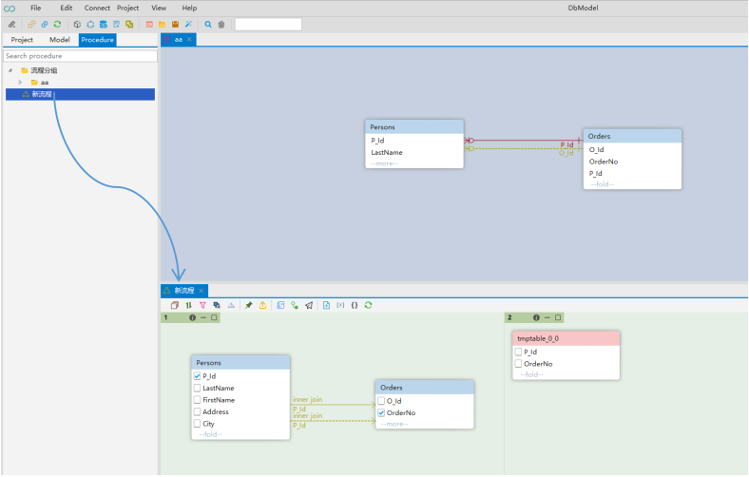

Procedure Toolbar
Icon | Item | Description
 | Group By | use the GROUP BY clause
 | Order By | use the Order BY clause
 | Join And/Or | Shortcut to create a join relationship
 | Set Distinct | Set Distinct to select clause
 | set join and | Add additional join conditions
 | lock | Lock temporary table.Locked tables do not advance to the next step
 | Table data export | Export data to other table, same as insert into clause
 | Generate temp table | Create a temporary table and insert the results of the current query into the table, same as create temp table XX as select ...
 | Generate  subqueries | A sub-query step is generated, For all concurrent process
 | Generate  next step | A sub-query step is generated, Only for the process corresponding to the current table.
 | create temp table | Create a temporary table to use for data processing in the SQL processing flow
 | create variable table | Create environment variables for the SQL context
 | Create code block | Hold SQL code copied from other place or manually written code that can be used to implement features not currently supported
 | Refresh | Used when the model relationship changes and the program prompts for a refresh

Add tables to Procedure Layout
There are two ways to add a table to a Procedure Layout view:
- Add tables from the Navigator tree panel by drag & drop.
- Add tables from the Model by drag & drop.
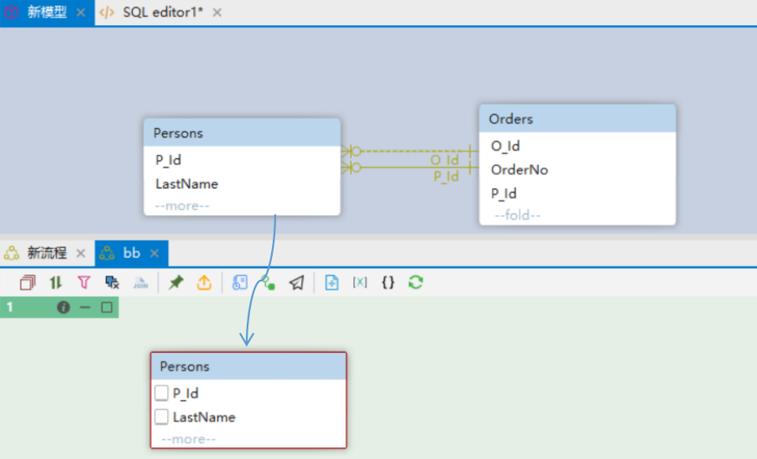

By dragging&dropping tables from the Project Navigator or Model View to the Procedure view, you can see the table view corresponding to the tables in the Procedure Workspace, right in the position where mouse button is released.
You can also add tables found by filtering Database Objects to the Sequence workspace. For information on how to filter Database objects in Project Navigator, please see the Filter Database Objects article.

A table object can be added to multiple steps, especially the same step.
If the table currently being added has a relational table and its relational table already exists in the process, the relationship is automatically established when it is added to the Sequence .

Remove Table View
Remove Table View means removing the table view from the current Procedure workspace. The actual table object is not deleted, as the table in the database navigation area still exists.
The deleted table view can be added to the workspace again as needed.
After a table that has established an relationship is removed from the model, the corresponding relationship will not be affected.

Establish Table Relationship
The operation of Establish Table Relationship is the same as that in the Model Design. Please refer to the Model Design section.
Unlike the primary and foreign key relationships established in the model, the lines in the procedure are directional which represents the positional relationship between the join tables .
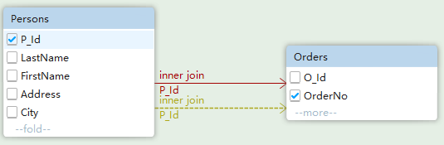

Foreign Key Routing
The operation of Foreign Key Routing is the same as that in the Model Design. Please refer to the Model Design section.

Change Foreign Key
Change Foreign Key includes :
- change the relation type of a foreign key
- Change join type
- change the direction of a foreign key. Direction means the position relationship between the left and right tables during join.

Change Foreign Key Type
Change Foreign Key Type is the same as Model Design, please refer to it.

Change Join Type
The default join type is inner join type, you can switch to different join types : INNER JOIN, LEFT JOIN, FULL JOIN ,etc. You can refer to Section Foreign Tools for the correct way to open the tool.

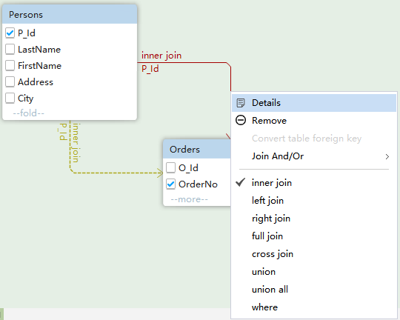

Change Foreign Key Direction
The foreign key direction represents the join position relationship between two associated tables, such as a join B, which becomes B join a after changing the direction.
When you establish a relationship by dragging&dropping, the target table defaults to the actual direction of the foreign key. You can change the positional relationship by deleting the connection and then reestablishing the relationship.
Note that deleting the foreign key relationship in the Sequencedoes not affect the model, but deleting the foreign key relationship in the model does affect the Sequence.

Choose the Columns to Select
Choose the columns to select by ticking the column checkboxes.
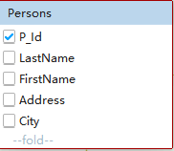

Step Information Window
Step Information is the main interface for query design. Most of the operations in the query can be completed in this interface.
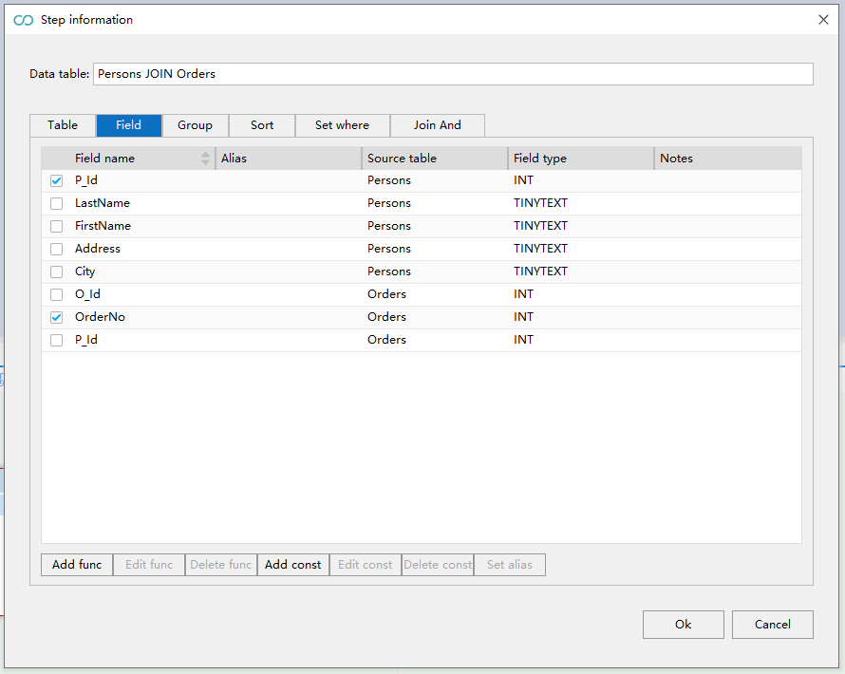

Tab | Description
Table | Displays the tables involved in the current join relationship
Field | Displays the list of fields involved in the current join relationship
Group | Displays the group settings
Sort | Displays the sort settings
Set where | Displays the filter criteria
Join and | Show primary foreign key join relationships

Where Conditions
Click the Set where button on the sequence toolbar to pop up the following dialog box:

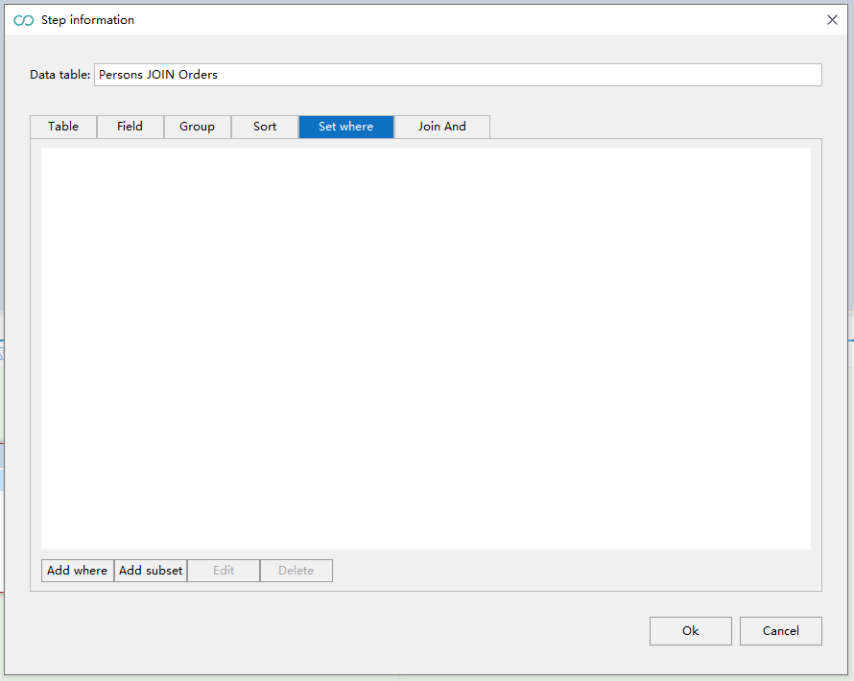
Item | Description
Add where | Add a where condition. You can add multiple where conditions.
Add subset | Add a where condition subset. A subset is a set of multiple where conditions. You can add multiple where condition subsets.
Edit | Edit a where condition or condition subset
Delete | Delete a where condition or condition subset

Add where
Open the Step information window, and click Add where to pop up the following dialog box:
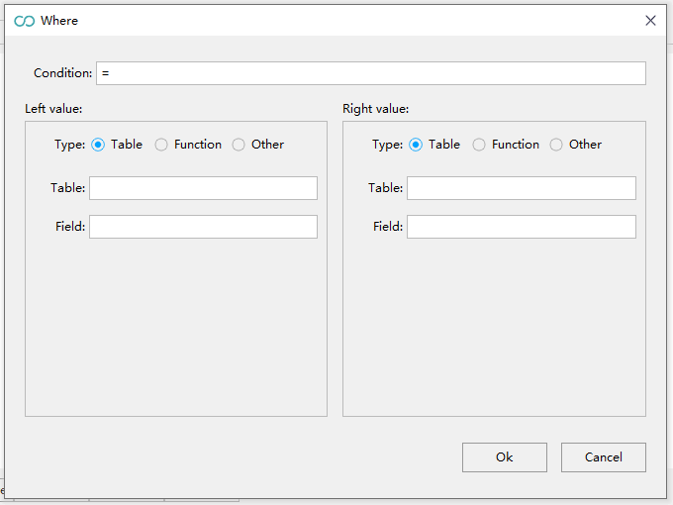
Item | Description
condition | Condition operator
Type:Table | When a table type is selected, the operand is a table field. The corresponding field value can be selected through the table and field edit box
Type:Function | When the function type is selected, the operand is a function.
Type:Other | User defined data

Add subset
Open the Step information window, and click Add subset to pop up the following dialog box:
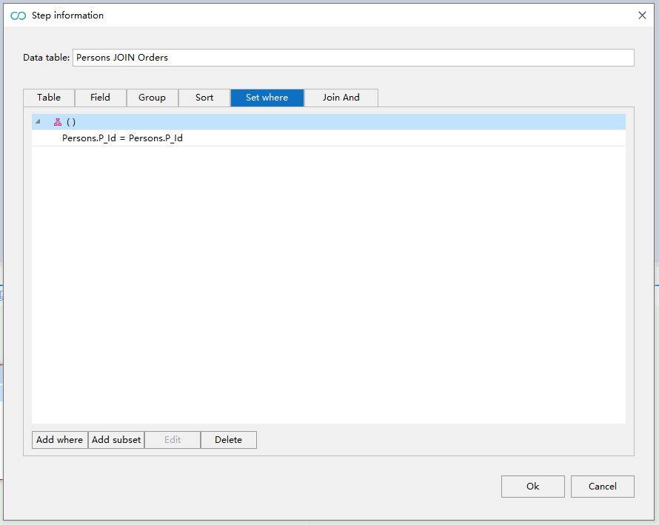
After adding a subset, you need to add a condition in the subset. The specific operation is the same as add where.

Join Further Tables to the Procedure
When add further tables to the layout view, If there is a relationship between the existing table and the table to be added, the relationship will be automatically established after the drag&drop. Since there is a position relationship between two tables, the table to be joined later is the target table by default.
The default join type is inner join type, you can switch to different join types: INNER JOIN, LEFT JOIN, FULL JOIN, etc.

Generate next step
There are several ways to generate the next step:
- Click the Generate temp table menu;
- Click the Generate subqueries menu;
- Click the Generate next step menu;
- Click the Table data export.
Refer to Section Sequence Toolbar for toolbar menu description.
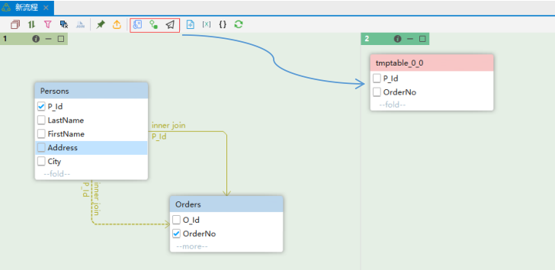

Execute Generated SQL
The generated SQL code is displayed on the right. Click the lightning icon in the upper-right corner to submit scripts to JDBC.
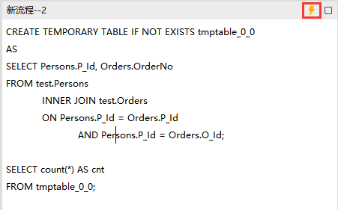

图标 | 项目 | 描述
 | Execute SQL | Execute all SQL statements. Multiple results will display only the last one in the pane.
 | Maximum | Maximize SQL Code Window

